Original Article

Knowledge Evolution in Self-Determination Theory Research in Higher Education: A Longitudinal Bibliometric Analysis of Scholarship
Evolución del conocimiento sobre la teoría de la autodeterminación en educación superior: un análisis bibliométrico longitudinal

Yifan Zhang^{1,2*}
E-mail: zhangyifan3402@gmail.com
ORCID: https://orcid.org/0009-0004-9405-7776
Ahmad Zamri Khairani³
E-mail: ahmadzamri@usm.my
ORCID: https://orcid.org/0000-0002-3832-8103

¹ National Higher Education Research Institute (IPPTN). Universiti Sains Malaysia No. 10. Persiaran Bukit Jambul 11900 Bayan Lepas. Penang. Malaysia
² Chengdu Polytechnic, No. 83 Tianyi Street High-Tech Zone. Chengdu. Sichuan 610041. China
³ School of Educational Studies, Universiti Sains Malaysia. 11800 Penang, Malaysia

*Corresponding author: Yifan Zhang. e-mail: zhangyifan3402@gmail.com

Suggested citation (APA, seventh ed.)
Zhang, Y., & Zamri Khairani, A (2026). Knowledge Evolution in Self-Determination Theory Research in Higher Education: A Longitudinal Bibliometric Analysis of Scholarship. Revista Conrado, 22(113), e

Abstract
Self-Determination Theory (SDT) has become a prominent framework in higher education research to explain student motivation, engagement, and well-being, particularly amid the expansion of online and hybrid learning and inclusivity agendas. Yet SDT-related knowledge in higher education is distributed across increasingly diverse application contexts, making it difficult to determine how thematic continuity, diversification, and structural integration have developed over time. This study examines the longitudinal development of knowledge surrounding SDT in higher education through a bibliometric approach. Using a reproducible search and screening workflow in Scopus (retrieved on 29 August 2024; final dataset: 862 records), we conduct (i) performance analysis of publication growth, citations, and leading contributors and (ii) science mapping using co-word thematic mapping and thematic evolution (Bibliometrix/Biblioshiny, complemented by data cleaning via OpenRefine and biblioMagika). Results show sharp post-2010 growth and a stable SDT-related conceptual reference point alongside the expansion and differentiated positioning of applied themes centered on motivation-related outcomes, inclusive education, and digitally mediated learning. The strategic maps further indicate that some application themes became internally developed and structurally connected, whereas others remained specialized or peripheral. This study offers a longitudinal account of knowledge development around SDT, clarifying the relationship between contextual expansion and selective structural integration while preserving the distinction between changes in the scholarship and changes in the theory itself.
Keywords: Self-determination theory, Higher education, Bibliometric analysis, Thematic evolution, Academic motivation

Resumen
La Teoría de la Autodeterminación (TAD) se ha consolidado como un marco destacado en la investigación sobre educación superior para explicar la motivación, el compromiso (engagement) y el bienestar de los estudiantes, especialmente en el contexto de la expansión del aprendizaje en línea e híbrido y de las agendas de inclusión. No obstante, el conocimiento vinculado a la TAD en la educación superior se distribuye entre contextos de aplicación cada vez más diversos, lo que dificulta determinar cómo han evolucionado la continuidad temática, la diversificación y la integración estructural a lo largo del tiempo. Este estudio examina el desarrollo longitudinal del conocimiento en torno a la TAD en la educación superior mediante un enfoque bibliométrico. A partir de un flujo de trabajo reproducible de búsqueda y cribado en Scopus (consulta realizada el 29 de agosto de 2024; conjunto de datos final: 862 registros), se llevó a cabo (i) un análisis de desempeño del crecimiento de las publicaciones, las citas y los principales contribuyentes, y (ii) un mapeo científico basado en el análisis de co-palabras mediante mapas temáticos y evolución temática (Bibliometrix/Biblioshiny, complementado con la depuración de datos a través de OpenRefine y biblioMagika). Los resultados muestran un marcado crecimiento a partir de 2010 y un punto de referencia conceptual estable asociado a la TAD, junto con la expansión y el posicionamiento diferenciado de temas aplicados centrados en los resultados relacionados con la motivación, la educación inclusiva y el aprendizaje mediado digitalmente. Los mapas estratégicos indican, además, que algunos temas de aplicación alcanzaron un desarrollo interno y una conexión estructural, mientras que otros permanecieron especializados o periféricos. Este estudio ofrece una descripción longitudinal del desarrollo del conocimiento en torno a la TAD, esclareciendo la relación entre la expansión contextual y la integración estructural selectiva, al tiempo que preserva la distinción entre los cambios en la producción académica y los cambios en la teoría misma.
Palabras clave: Teoría de la autodeterminación, Educación Superior, Análisis bibliométrico, Evolución temática, Motivación académica

Received: September 29, 2025
Accepted: March 21, 2026

Introduction
The development of knowledge surrounding Self-Determination Theory (SDT) in higher education reflects sustained scholarly efforts to understand student motivation and engagement across increasingly diverse learning environments. These concerns remain central as institutions seek to support academic performance, persistence, and well-being (Ferrer et al., 2022; Morris, 2019). SDT provides an established framework for this research by emphasizing the roles of autonomy, competence, and relatedness in shaping the quality of human motivation (Ryan & Deci, 2023). Although applied across multiple disciplines, SDT has assumed particular importance in education, where it informs research on how learning environments and instructional practices support or constrain students’ psychological needs.
As the use of SDT in higher education has grown, so too has the body of knowledge associated with the theory. Research now extends beyond traditional classroom instruction to online and hybrid learning, student transitions, professional education, inclusive education, and the experiences of diverse learner groups (De Freitas et al., 2022; Larson et al., 2019; Lozano-Jiménez et al., 2021). Yet publication growth alone cannot explain how this knowledge has developed. A research domain may expand and diversify contextually while retaining a stable conceptual foundation. New applications may become integrated with established motivational concepts, develop into specialized research niches, or remain weakly connected to the wider knowledge structure. Distinguishing the expansion of SDT-related scholarship from the development of SDT as a theory is therefore essential.
Despite this growth, existing research has largely generated evidence on particular SDT constructs and applications, including autonomy support, intrinsic motivation, psychological need satisfaction, and digitally mediated learning (Ferrer et al., 2022; Holzer et al., 2021). Studies focused on individual constructs or settings, however, do not reveal how the knowledge surrounding SDT has been organized and reorganized over time. Conventional bibliometric descriptions of publication trends, influential contributors, and static thematic structures characterize the scale and composition of a field but offer limited insight into whether themes persist, become structurally integrated, develop into specialized domains, or lose connection with the wider literature. The unresolved issue is therefore not simply whether SDT-related higher education research has increased or which themes are prominent, but how its knowledge structure has developed through continuity, expansion, diversification, and changing thematic relationships.
To address this gap, the present study conducts a longitudinal bibliometric analysis of 862 Scopus-indexed documents published between 1979 and 2024. Performance indicators and contributor patterns establish the descriptive context for the field’s expansion, while author-keyword thematic evolution and strategic maps provide evidence of thematic continuity, structural position, and internal development across three periods. The analysis examines how the publication base of SDT-related higher education research has expanded, which knowledge themes have remained structurally persistent or changed position, and how newer application domains have become integrated, specialized, or weakly connected within the broader field.
In doing so, the study offers an empirically bounded account of knowledge development around a stable theoretical framework. It does not seek to demonstrate that SDT’s propositions or mechanisms have changed. Rather, it explains how the scholarly knowledge organized around SDT has broadened across higher education contexts while exhibiting different degrees of structural integration. This perspective clarifies the relationship between contextual expansion and cumulative knowledge formation, providing a coherent basis for identifying future research priorities.
SDT, developed by Ryan & Deci (2019), is a broad framework for the study of human motivation that emphasizes the innate psychological needs of autonomy, competence, and relatedness (Larson et al., 2019). These needs are fundamental to optimal functioning and well-being, particularly in educational settings. Autonomy refers to the sense of volition and self-direction in learning; competence involves feeling capable and effective in academic tasks; and relatedness pertains to the connection and sense of belonging with peers and educators. SDT distinguishes between intrinsic motivation (engaging in activities for inherent satisfaction) and extrinsic motivation (engaging in activities for external rewards or pressures), arguing that educational environments should foster conditions that promote intrinsic motivation for deep learning, and sustained academic engagement.
SDT has been extensively applied in higher education to understand how learning environments can support student motivation and engagement (Ferrer et al., 2022). Research suggests that when instructors employ supportive teaching practices such as autonomy-supportive instruction, constructive feedback, and collaborative learning, students experience higher intrinsic motivation, increased persistence, and improved academic performance (Reeve, 2012). Moreover, SDT has provided valuable insights into online learning, where fostering autonomy and competence through well-structured digital platforms can enhance students’ sense of agency and reduce their disengagement (Hsu et al., 2019).
Several empirical studies have tested SDT’s application of SDT in higher-education settings. Holzer et al. (2021) used structural equation modeling in higher education to examine how psychological need satisfaction influences well-being during COVID-19, finding competence to be the strongest predictor of positive emotion and motivation. Ferrer et al. (2022) used structural equation modeling in higher education to examine how students' attitudes toward online learning mediate the relationship between motivation and engagement. The results showed that attitude influenced engagement for both intrinsic and extrinsic motivation, with stronger effects on online students.
Bai et al. (2022) used structural equation modeling in higher education to examine how perceived fear, course quality, and self-determination influence learners’ retention intention in MOOCs. The results showed that course quality and intrinsic motivation significantly enhanced perceived usefulness and satisfaction, and increased retention rates.
While SDT research in higher education has expanded significantly, the literature remains fragmented, with studies often focusing on specific components, such as autonomy support or motivation types, without synthesizing broader trends. To address this gap, bibliometric analysis provides a valuable method for mapping research evolution, identifying key contributors, and uncovering emerging themes. Few studies have applied bibliometric techniques to SDT research in higher education, making it challenging for scholars to gain a comprehensive understanding of this field’s development. Given this limitation, this study employs bibliometric tools, such as VOSviewer and Biblioshiny, to systematically analyze SDT-related publications, offering insights into research trends, author collaborations, and thematic evolution.

Materials and methods

Bibliographic data were retrieved from Scopus, a multidisciplinary database providing structured metadata suitable for bibliometric analysis, including citation records, author affiliations, and geographical information. The search was conducted on August 29, 2024, using the TITLE-ABS-KEY field, covering publication titles, abstracts, and keywords. No publication-year restrictions were applied, and all document types were initially considered. The search was limited to English-language records to ensure consistency in thematic analysis. Boolean operators, alternative expressions, and truncation were employed to identify relevant publications. The search equation was:
(TITLE-ABS-KEY ("self-determination theory" OR "self-determination theory" OR "theory of self-determination" OR "SDT")) AND (TITLE-ABS-KEY ("higher education" OR "higher education institution*" OR "tertiary education" OR "post-secondary education" OR post-secondary OR college OR universit* OR "higher learning")
The search strategy encompassed theoretical and empirical studies addressing Self-Determination Theory (SDT) across different higher education settings. The identification and selection process was documented through a PRISMA-informed flow diagram (Moher et al., 2009), presented in Figure 1. Two reviewers independently screened titles and abstracts, resolving disagreements through consensus. Errata and notes were excluded because they did not represent substantive research contributions. The final dataset comprised 862 documents, whose distribution by publication type is presented in Table 2.
Bibliographic records were cleaned and standardized using biblioMagika 2.9 and OpenRefine 3.7.6. The process addressed inconsistencies in author names, identifiers, institutional affiliations, countries, and keywords. OpenRefine facilitated the identification and correction of terminological variations, while biblioMagika supported the harmonization of bibliographic metadata. These procedures improved data consistency and reliability for subsequent bibliometric analyses.
The 862 records were imported into Biblioshiny, the graphical interface of Bibliometrix 4.3.0 for R (Aria & Cuccurullo, 2017), to examine publication trends, citation indicators, leading authors, institutional contributions, and geographical distribution. Scientific mapping techniques, including co-word analysis, thematic evolution, and strategic thematic maps, were employed to identify the continuity, diversification, and structural relationships of research themes. This combined approach enabled a longitudinal assessment of knowledge development surrounding SDT in higher education while distinguishing changes in scholarly production and thematic organization from modifications to the theory itself (Figure 1).

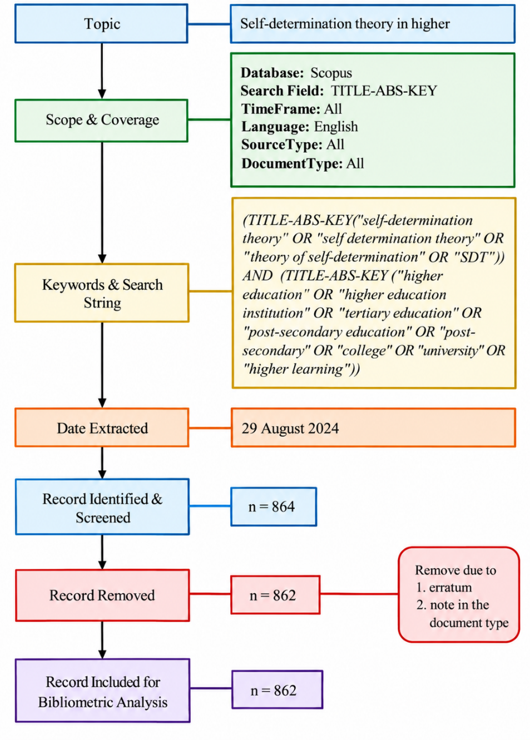
Figure 1: Flowchart of the search, screening, and inclusion process for the bibliometric analysis of self-determination theory in higher education

Results and discussion

The bibliometric analysis highlighted key citation metrics for research on SDT in HE from 1979 to 2024, as presented in Table 1. Over the 46-year publication period, 862 publications were produced by 2,753 authors, documenting the scale of the field’s authorship base. These studies received 11,993 citations. The mean number of citations per paper was 13.90. However, the 635 cited publications received an average of 18.87 citations each, indicating the citation impact of the referenced studies within the literature.
The citation profile of the field, as shown in Table 1, includes an h-index of 51 and a g-index of 84, indicating a substantial body of highly cited work. The m-index of 1.109 contextualizes the h-index in relation to the length of the publication period. Furthermore, the 9,947 citations within the h-core show that a substantial proportion of the field’s citation influence is concentrated among its most prominent articles. Together, these measures indicate the citation visibility accumulated by SDT-related higher education research.

Table 1: Citation metrics
Main Information | Data
Publication Years | 1979 - 2024
Total Publications | 862
Citable Year | 46
Number of Contributing Authors | 2753
Number of Cited Papers | 635
Total Citations | 11,993
Citation per Paper | 13.90
Citation per Cited Paper | 18.87
Citation per Year | 266.29
Citation per Author | 4.35
Author per Paper | 3.19
Citation sum within h-Core | 9,947
h-index | 51
g-index | 84
m-index | 1.109

The analysis of document types related to SDT in HE, as presented in Table 2, identified 862 publications, the majority of which were articles, accounting for 80.90% (699). This frequency highlights peer-reviewed articles as the principal vehicle for disseminating original research and theoretical insights within the academic community. Conference papers represented 7.64% (66) of the total, reflecting their role in communicating preliminary findings and facilitating scholarly exchange. Book chapters accounted for 6.02% (52), showing that edited-volume publications also contributed to the corpus. Review articles represented 3.59% (31), while books and conference reviews accounted for 1.04% (9) and 0.58% (5), respectively. This distribution describes the range of publication formats through which SDT-related knowledge has been disseminated.

Table 2: Document Type
Document Type | Total Publications | Percentage (%)
Article | 699 | 80.90%
Conference Paper | 66 | 7.64%
Book Chapter | 52 | 6.02%
Review | 31 | 3.59%
Book | 9 | 1.04%
Conference Review | 5 | 0.58%
Total | 862 | 100.00

The analysis of source types related to SDT in HE, as outlined in Table 3, revealed that publications predominantly originated from journals, accounting for 84.61% (731) of the total output. This proportion demonstrates the central role of academic journals in disseminating peer-reviewed SDT-related research. Conference proceedings comprised 6.25% (54), while books accounted for 5.67% (49) and book series represented 3.47% (30).

Table 3: Source Type.
Source Type | Total Publications | Percentage (%)
Journal | 731 | 84.61%
Conference Proceeding | 54 | 6.25%
Book | 49 | 5.67%
Book Series | 30 | 3.47%
Total | 862 | 100.00

The analysis of subject areas related to SDT in HE, as presented in Table 4, reveals a diverse academic landscape. Social sciences emerged as the predominant category, accounting for 72.45% (626) of the total output. This representation reflects the centrality of social-science perspectives in examining human behaviour and motivation within educational contexts. Psychology constituted 20.49% (177) of the publications, reflecting its foundational role in developing and applying SDT principles. Computer science accounted for 11.69% (101), showing that technology-related research forms part of the multidisciplinary knowledge base surrounding SDT, particularly in online and hybrid educational environments. Contributions from medicine, business and management, the arts and humanities, health professions, engineering, and other areas further demonstrate the multidisciplinary application of SDT.

Table 4: Subject Area
Subject Area | Total Publications | Percentage (%)
Social Sciences | 626 | 72.45%
Psychology | 177 | 20.49%
Computer Science | 101 | 11.69%
Medicine | 88 | 10.19%
Business, Management and Accounting | 86 | 9.95%
Arts and Humanities | 69 | 7.99%
Health Professions | 60 | 6.94%
Engineering | 44 | 5.09%
Environmental Science | 39 | 4.51%
Energy | 24 | 2.78%
Economics, Econometrics and Finance | 17 | 1.97%
Neuroscience | 15 | 1.74%
Decision Sciences | 14 | 1.62%
Mathematics | 13 | 1.50%
Multidisciplinary | 13 | 1.50%
Nursing | 8 | 0.93%
Chemistry | 7 | 0.81%
Earth and Planetary Sciences | 7 | 0.81%
Agricultural and Biological Sciences | 6 | 0.69%
Biochemistry, Genetics and Molecular Biology | 6 | 0.69%
Materials Science | 4 | 0.46%
Physics and Astronomy | 4 | 0.46%
Dentistry | 2 | 0.23%
Pharmacology, Toxicology and Pharmaceutics | 2 | 0.23%
Chemical Engineering | 1 | 0.12%
Immunology and Microbiology | 1 | 0.12%
Veterinary | 1 | 0.12%

Figure 2 presents the temporal distribution of publications and citations related to SDT in HE. The blue bars indicate the total number of publications per year, whereas the orange line represents the corresponding annual citations. Publication and citation activity remained limited from 1979 to the early 2000s, with relatively few publications each year and minimal citation activity. The increase in publications became more pronounced around 2010 and coincided with growth in citations. The most substantial increase in both measures occurred between 2015 and 2023, indicating increasing academic attention to the topic.
The number of publications peaked in 2023 at 151, while publications from that year had accumulated 336 citations at the time of data retrieval. This difference between recent publication output and citation counts reflects the natural citation lag, as recently published work has had less time to accumulate citations. The figures for 2024—96 publications and 70 citations—should also be interpreted in light of the incomplete publication year and the limited time available for citation accumulation.

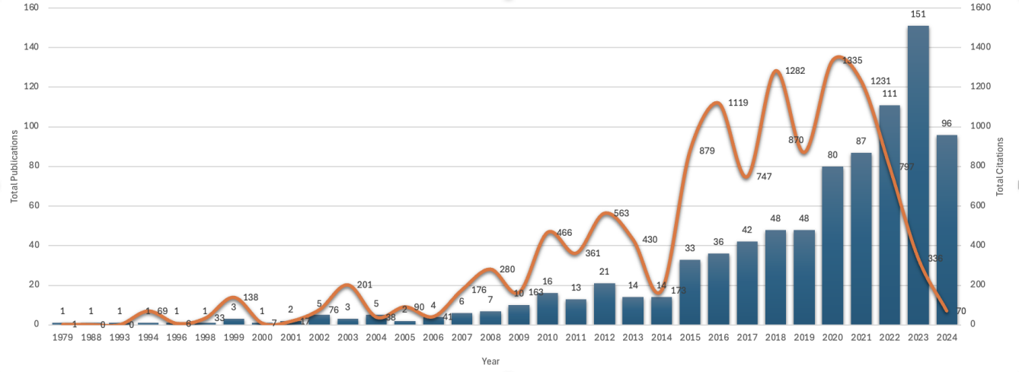

Figure 2: Total Publications and Citations by Year.

Table 5 presents the most influential authors in SDT research, identified by an h-index greater than three. Karrie A. Shogren of the University of Kansas recorded the highest h-index of 9, with ten publications and 225 citations, corresponding to an average of 22.50 citations per publication. Lucas M. Jeno of the University of Bergen had an h-index of 6 and received 254 citations across nine publications, with an average of 28.22 citations per publication. Chantal Levesque-Bristol of Purdue University received the highest total number of citations among the listed authors, with 377 citations and an average of 47.13 citations per cited publication. The research profiles of these leading contributors are closely associated with self-determination theory and motivation, including the application of SDT across different educational contexts.

Table 5: Most Influential Authors by H-Index>3
Author’s Name | Current Affiliation | Country | TP | NCP | TC | C/P | C/CP | h | g | m
Shogren, Karrie A. | University of Kansas | United States | 10 | 10 | 225 | 22.50 | 22.50 | 9 | 10 | 0.692
Jeno, Lucas M. | University of Bergen | Norway | 9 | 8 | 254 | 28.22 | 31.75 | 6 | 9 | 0.750
Levesque-Bristol, Chantal | Purdue University | United States | 9 | 8 | 377 | 41.89 | 47.13 | 7 | 9 | 1.167
Kaur, Amrita | Wenzhou-Kean University | China | 7 | 6 | 75 | 10.71 | 12.50 | 5 | 7 | 0.833
Moreno-Murcia, Juan Antonio | Miguel Hernández University | Spain | 6 | 5 | 86 | 14.33 | 17.20 | 4 | 6 | 0.500
Wehmeyer, Michael L. | University of Kansas | United States | 5 | 4 | 81 | 16.20 | 20.25 | 3 | 5 | 0.158
Hernández, Elisa Huéscar | Miguel Hernández University | Spain | 5 | 4 | 78 | 15.60 | 19.50 | 4 | 5 | 0.500
Bonem, Emily M. | Purdue University | United States | 4 | 4 | 161 | 40.25 | 40.25 | 4 | 4 | 0.667
Wang, Cong | Yale University | United States | 4 | 4 | 140 | 35.00 | 35.00 | 4 | 4 | 0.667
Awang-Hashim, Rosna | Universiti Utara Malaysia | Malaysia | 4 | 4 | 50 | 12.50 | 12.50 | 4 | 4 | 0.800
Stupnisky, Robert | University of North Dakota | United States | 4 | 4 | 264 | 66.00 | 66.00 | 4 | 4 | 0.500
Notes: TP=total number of publications; NCA=Number of contributing authors; NCP=number of cited publications; TC=total citations; C/P=average citations per publication; C/CP=average citations per cited publication; h=h-index; g=g-index; and m=m-index.
Table 6 presents the most productive institutions contributing to SDT research in HE, based on an h-index exceeding four. Purdue University received the highest total number of citations (593) and recorded an h-index of 10 based on 15 publications, with an average of 39.53 citations per publication. The University of Kansas also recorded an h-index of 10, based on 19 publications and 314 citations. Its average number of citations per publication was 16.53.
Other prominent institutions included KU Leuven in Belgium and Curtin University in Australia, both of which recorded an h-index of 6. KU Leuven produced seven publications with an average of 33.14 citations per publication, whereas Curtin University produced eight publications with an average of 13.50 citations per publication. Universiti Utara Malaysia also recorded an h-index of 6, with eight publications and 91 citations. Table 6 reflects the geographical distribution of contributing institutions across North America, Europe, Asia, and Australia, with varying levels of publication output and citation impact.

Table 6: Most productive institutions by H-Index>4.
Affiliation | Country | TP | NCA | NCP | TC | C/P | C/CP | h | g | m
Purdue University | United States | 15 | 42 | 12 | 593 | 39.53 | 49.42 | 10 | 15 | 1.667
University of Kansas | United States | 19 | 47 | 17 | 314 | 16.53 | 18.47 | 10 | 17 | 0.526
KU Leuven | Belgium | 7 | 10 | 7 | 232 | 33.14 | 33.14 | 6 | 7 | 0.500
Curtin University | Australia | 8 | 24 | 7 | 108 | 13.50 | 15.43 | 6 | 8 | 0.500
University of Bergen | Norway | 9 | 30 | 8 | 254 | 28.22 | 31.75 | 6 | 9 | 0.750
Universiti Utara Malaysia | Malaysia | 8 | 20 | 8 | 91 | 11.38 | 11.38 | 6 | 8 | 1.000
Portland State University | United States | 6 | 18 | 6 | 169 | 28.17 | 28.17 | 5 | 6 | 0.217
University of Hong Kong | China | 5 | 8 | 5 | 301 | 60.20 | 60.20 | 5 | 5 | 0.500
University of Toronto | Canada | 9 | 18 | 9 | 86 | 9.56 | 9.56 | 5 | 9 | 0.313
The Education University of Hong Kong | China | 6 | 14 | 6 | 85 | 14.17 | 14.17 | 5 | 6 | 0.625
Notes: TP=total number of publications; NCA=number of contributing authors; NCP=number of cited publications; TC=total citations; C/P=average citations per publication; C/CP=average citations per cited publication; h=h-index; g=g-index; and m=m-index.

Publications by Countries
Figure 3 maps the global contributions to SDT research in HE, while Table 7 ranks the most influential countries by h-index. The United States, China, and the United Kingdom are represented by darker shading in Figure 3, indicating their higher publication output. The United States leads with 231 publications, 4,383 citations, and an h-index of 36. China follows with 80 publications, 1,019 citations, and an h-index of 16, while the United Kingdom produced 55 publications and also recorded an h-index of 16. Australia, Canada, Germany, Malaysia, Belgium, and Spain also contributed substantially to the field. Collectively, Table 7 and Figure 3 document the international distribution of SDT-related higher education research and the differing levels of productivity and citation visibility across countries.

Table 7: Most influential Countries by H-Index>9.
Country | TP | NCA | NCP | TC | C/P | C/CP | h | g | m
United States | 231 | 687 | 190 | 4383 | 18.97 | 23.07 | 36 | 66 | 0.783
China | 80 | 207 | 60 | 1019 | 12.74 | 16.98 | 16 | 31 | 0.941
United Kingdom | 55 | 100 | 42 | 939 | 17.07 | 22.36 | 16 | 30 | 0.615
Australia | 57 | 171 | 43 | 975 | 17.11 | 22.67 | 15 | 31 | 0.652
Canada | 41 | 110 | 33 | 506 | 12.34 | 15.33 | 13 | 22 | 0.500
Germany | 39 | 91 | 30 | 866 | 22.21 | 28.87 | 13 | 29 | 0.722
Malaysia | 37 | 99 | 32 | 303 | 8.19 | 9.47 | 12 | 17 | 0.800
Belgium | 13 | 52 | 13 | 528 | 40.62 | 40.62 | 10 | 13 | 0.833
Spain | 35 | 102 | 27 | 414 | 11.83 | 15.33 | 10 | 20 | 0.714
Notes: TP=total number of publications; NCA=number of contributing authors; NCP=number of cited publications; TC=total citations; C/P=average citations per publication; C/CP=average citations per cited publication; h=h-index; g=g-index.

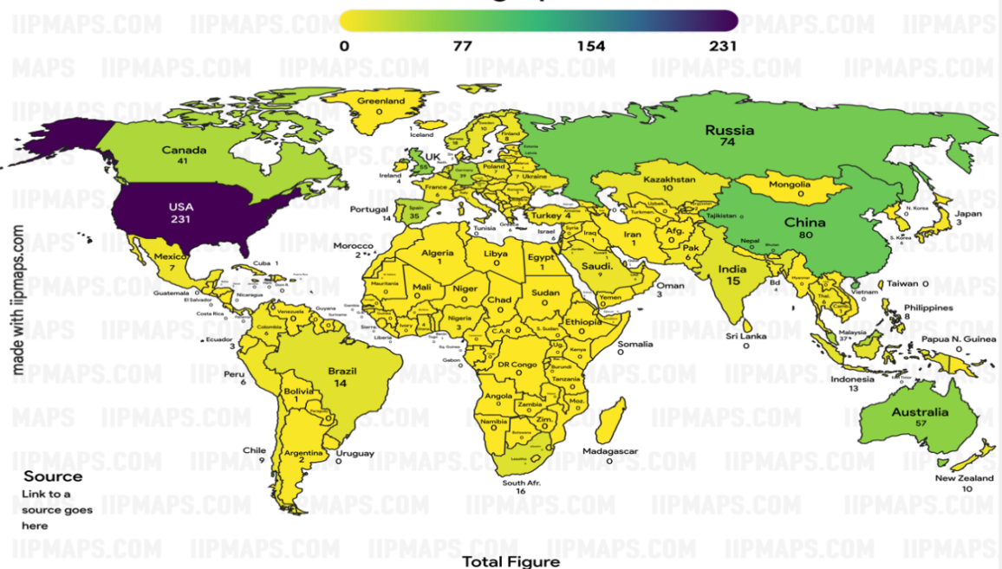
Figure 3: Scopus-indexed global social science results on self-determination theory in higher education.
Source: Generated by the author(s) using iipmaps.com

Conceptual structure analysis examines relationships among research concepts and identifies prominent and emerging topics within a knowledge domain (Boyack & Klavans, 2014; Aria & Cuccurullo, 2017). Using Biblioshiny, author-keyword thematic evolution and strategic maps were generated to examine the development of research on Self-Determination Theory (SDT) in higher education across three periods: 1979–2018, 2019–2022, and 2023–2024. Figure 4 illustrates thematic continuity, divergence, and convergence, while Figures 5–7 classify keyword clusters into motor, niche, emerging or declining, and basic themes according to centrality and density.
The analysis included 250 keywords, a minimum cluster frequency of 10 per thousand documents, and a word-weighted inclusion index. Thematic maps displayed three labels per cluster, which were manually positioned to improve readability. During 1979–2018, research emphasized policy, neoliberalism, SDT, and academic achievement. Between 2019 and 2022, the thematic structure diversified toward intrinsic motivation, autonomy, professional self-determination, engineering education, digital skills, student satisfaction, and international students. In 2023–2024, research expanded into digitally mediated and inclusive educational contexts, including e-learning, online teaching, flipped classrooms, active learning, learning disabilities, and inclusive education. Overall, the thematic evolution reveals increasing diversification of SDT applications while maintaining continuity in its underlying motivational framework.
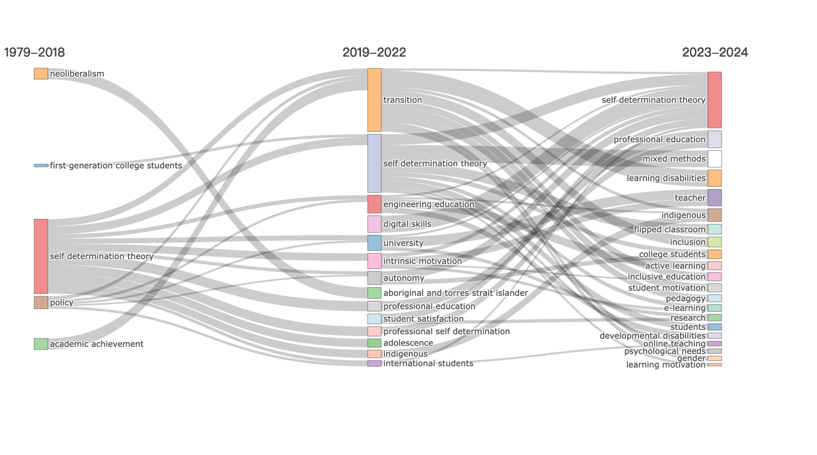
Figure 4: The thematic evolution map of the author's keywords

Thematic maps categorize research topics into four quadrants based on centrality and density Thematic maps were interpreted following (Callon et al., 1991; Cobo et al., 2011), using centrality to assess connections between themes and density to measure internal cohesion. Circle size represents keyword frequency within each cluster. Four thematic categories were distinguished: motor themes (high centrality and density), niche themes (high density and low centrality), emerging or declining themes (low centrality and density), and basic themes (high centrality and low density).
Figure 5 identifies seven keyword clusters during 1979–2018. "Policy" emerged as the only motor theme, while "self-determination theory" and "academic achievement" occupied the basic-theme quadrant. "Pre-university education" appeared as a niche theme, whereas "first-generation college students" and "neoliberalism" occupied transitional positions near quadrant boundaries. The "system of vocational and educational training" was classified as an emerging or declining theme. Overall, the thematic structure reflected the prominence of educational policy and the comparatively limited consolidation of SDT applications in higher education.
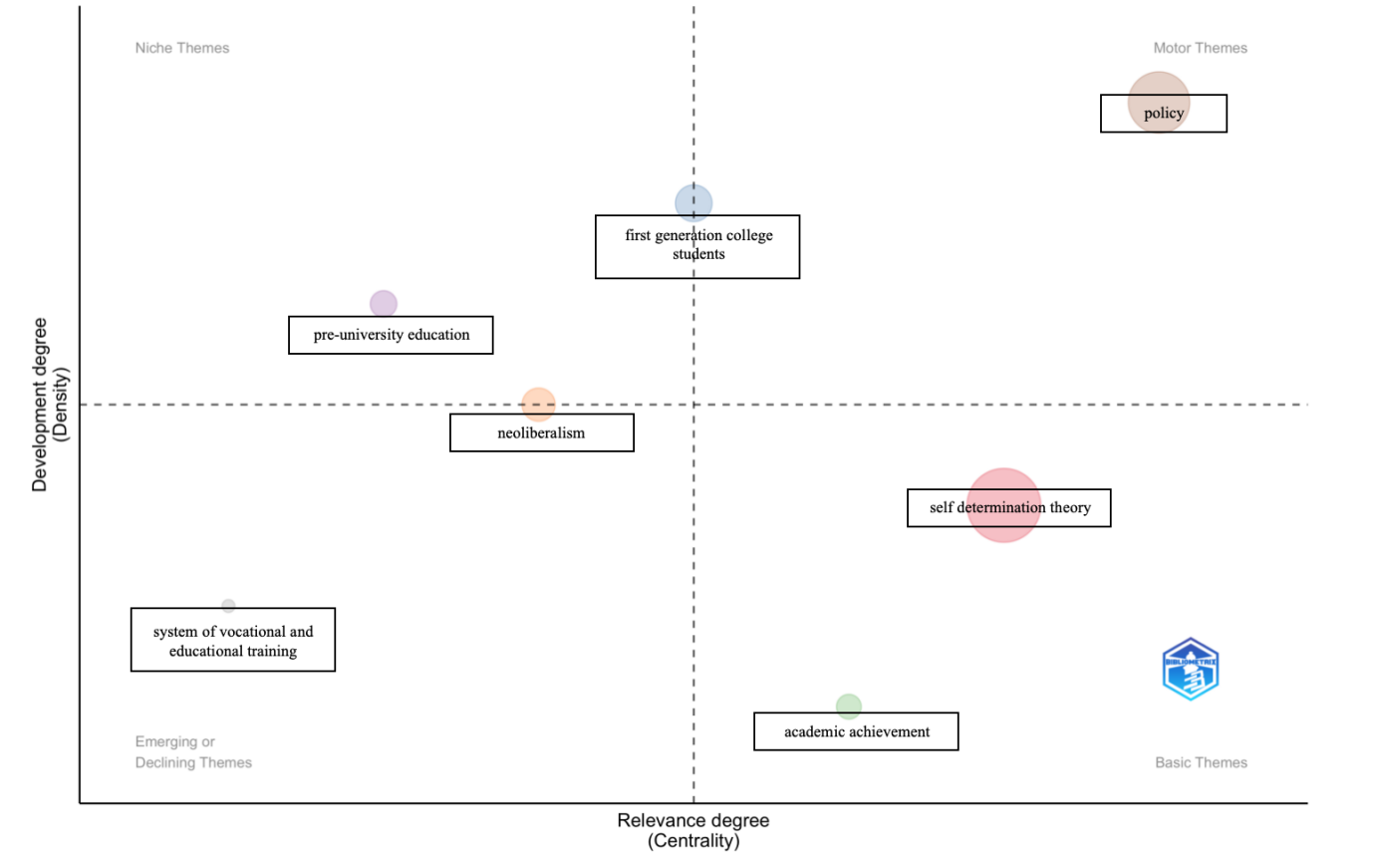
Figure 5: Thematic map (1979–2018)

Figure 6 presents 15 keyword clusters for 2019–2022, reflecting greater thematic diversification. "Intrinsic motivation," "engineering education," and "university" emerged as motor themes, characterized by high centrality and density. "Professional education," "student satisfaction," and "digital skills" appeared as niche themes, while "professional self-determination," "Indigenous/Aboriginal and Torres Strait Islander," and "adolescence" occupied the emerging-or-declining quadrant. "Self-determination theory," "autonomy," "international students," and "transition" remained basic themes, maintaining strong connections within the research network. "Cognition" occupied a transitional position between niche and motor themes. Overall, the findings indicate increasing thematic specialization alongside the continued centrality of SDT-related concepts.

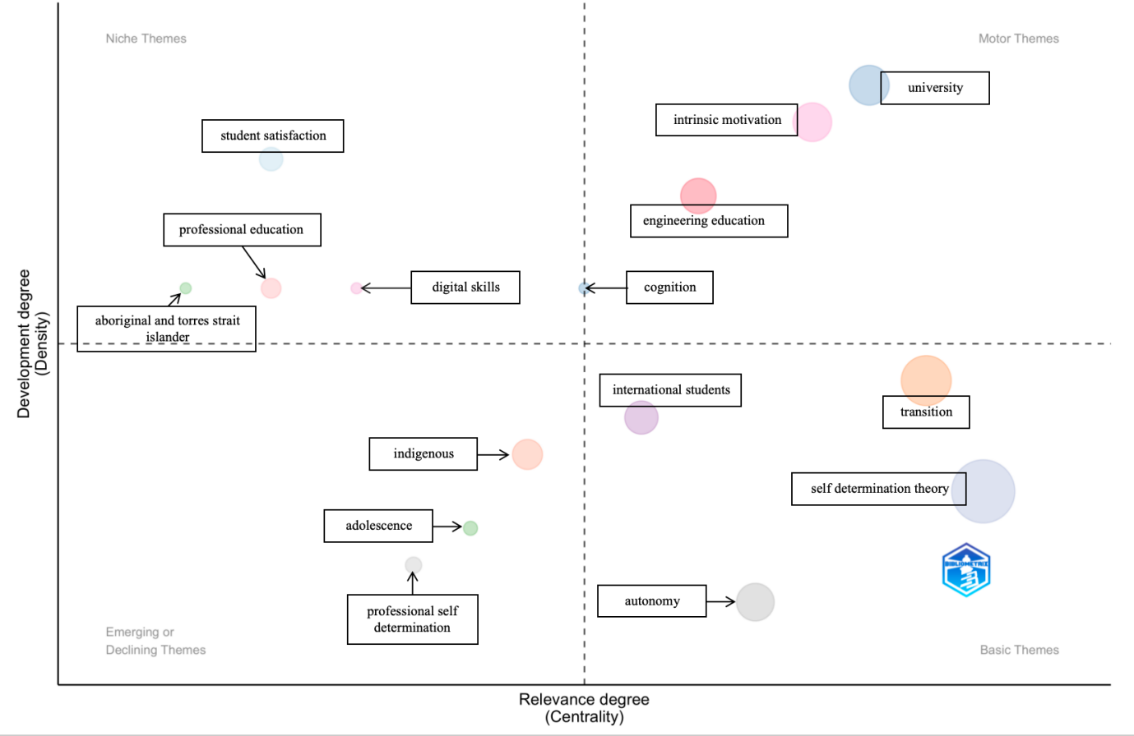
Figure 6: Thematic map (2019–2022).

As illustrated in Figure 7, the 2023–2024 period comprised 32 distinct clusters. The thematic configuration was anchored by motor themes such as inclusive education and expectancy-confirmation theory, which occupied central and internally developed positions. Specific pedagogical and methodological themes, including active learning and mixed method, appeared in the niche or emerging-or-declining quadrants, indicating that these areas were developing but remained comparatively weakly connected with the broader network.
Self-determination theory continued to occupy the basic-theme quadrant alongside gender features and inclusion. This recurring position indicates that the SDT cluster retained high centrality in the author-keyword network while displaying lower internal density than the motor themes. E-learning occupied a position towards the motor-theme quadrant, whereas online teaching remained a basic theme. These positions indicate that digitally mediated learning had acquired a visible but structurally differentiated place within the recent thematic configuration.

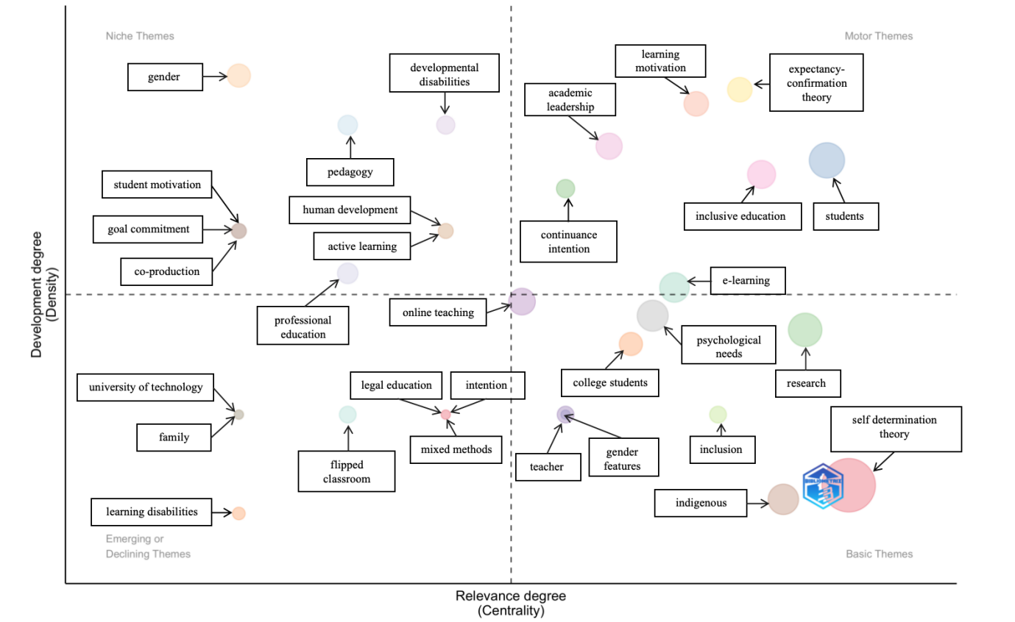
Figure 7: Thematic map (2023–2024).

Collectively, the thematic maps reveal a transition from policy-oriented research toward more diversified applications involving inclusive education, digital learning, and specialized pedagogical approaches. Self-Determination Theory (SDT) remained a basic theme throughout the three periods, indicating conceptual continuity despite changes in thematic organization. Its persistent centrality, together with intrinsic motivation and autonomy, reinforces its role as a foundational framework for understanding motivation and psychological needs.
Research progressively expanded into digital, inclusive, and learner-specific educational contexts (Qureshi et al., 2024). The growing prominence of psychological needs and inclusive education reflects broader educational applications (Lage et al., 2000; Pelikan et al., 2021), while e-learning and online teaching gained visibility, particularly during the COVID-19 pandemic (Holzer et al., 2021). Research involving Indigenous learners and students with developmental disabilities further diversified the field (Gow et al., 2020). Nevertheless, thematic integration remained uneven: motor themes exhibited stronger internal cohesion and connectivity, whereas niche and peripheral themes remained less integrated. Associations between SDT concepts and digital or hybrid learning environments (Akram & Li, 2024) indicate expanding applications rather than demonstrated theoretical modifications or intervention effectiveness. Overall, the findings demonstrate contextual diversification around a stable motivational framework, with varying degrees of thematic consolidation.
This study has several limitations. Its reliance on Scopus, English-language publications, and author-provided keywords restricts bibliographic coverage and may overlook relevant concepts or studies. Moreover, variations in search strategies, keyword standardization, analytical thresholds, and temporal divisions may influence thematic configurations. Bibliometric mapping identifies structural relationships but cannot establish causal mechanisms, theoretical development, intervention effectiveness, or the substantive quality of research contributions. Similarly, low centrality and density do not independently distinguish emerging from declining themes.
Future research should integrate bibliometric analysis with systematic literature reviews, content analysis, and empirical approaches to examine the conceptual relationships underlying thematic clusters. Comparative and longitudinal investigations across cultural, digital, inclusive, and learner-specific educational contexts could clarify the applicability of SDT and the transferability of findings. Particular attention should be given to psychological needs, online learning, cognitive and affective processes, and inclusive pedagogical practices. Such approaches would strengthen understanding of knowledge accumulation and identify opportunities for theoretical and practical integration without equating bibliometric changes with modifications to SDT itself.

Conclusions

This study examined how knowledge surrounding SDT in higher education developed across 862 Scopus-indexed documents published between 1979 and 2024. The evidence indicates a mixed trajectory: an enduring SDT-related motivational core provided continuity, while the surrounding literature diversified into new educational settings and learner populations. Integration was selective rather than uniform, with some themes becoming more cohesive and central and others remaining specialized or weakly connected.
The study’s contribution is therefore a longitudinal diagnosis of knowledge development around a stable theoretical framework. It distinguishes growth in research activity and contextual reach from stronger evidence of cumulative conceptual development. The findings do not show that SDT’s constructs or mechanisms changed; rather, they show that scholarship around SDT expanded, diversified, and consolidated unevenly. This distinction provides a more precise account of the field’s development and establishes longitudinal structural change as the study’s distinctive contribution.

References

Akram, H., & Li, S. (2024). Understanding the role of teacher-student relationships in students’ online learning engagement: Mediating role of academic motivation. Perceptual and Motor Skills, 131(4), 1415–1438. https://doi.org/10.1177/00315125241248709
Aria, M., & Cuccurullo, C. (2017). Bibliometrix: An R-tool for comprehensive science mapping analysis. Journal of Informetrics, 11(4), 959–975. https://doi.org/10.1016/j.joi.2017.08.007
Bai, X, Hossain, M. N., Kumar, N. (2022). Effect of Perceived Fear, Quality, and Self-Determination on Learners’ Retention Intention on MOOCs Psychology Research and Behavior Management, 15, 2843—2857. https://doi.org/10.2147/PRBM.S379378
Boyack, K. W., & Klavans, R. (2014). Creation of a highly detailed, dynamic, global model and map of science. Journal of the Association for Information Science and Technology, 65(4), 670–685. https://doi.org/10.1002/asi.22990
Callon, M., Courtial, J. P., & Laville, F. (1991). Co-word analysis as a tool for describing the network of interactions between basic and technological research: The case of polymer chemistry. Scientometrics, 22(1), 155–205. https://doi.org/10.1007/BF02019280
Cobo, M. J., López-Herrera, A. G., Herrera-Viedma, E., & Herrera, F. (2011). Science mapping software tools: Review, analysis, and cooperative study among tools. Journal of the American Society for Information Science and Technology, 62(7), 1382–1402. https://doi.org/10.1002/asi.21525
De Freitas, S., Waring, P., Douglas, H. E., Curtis, G. J., & Ritchie, S. M. (2022). Delivering blended learning to transnational students: Students’ perceptions and needs-satisfaction. Studies in Higher Education, 47(9), 1890–1902. https://doi.org/10.1080/03075079.2021.1983533
Ferrer, J., Ringer, A., Saville, K., Parris, M. A., & Kashi, K. (2022). Students’ motivation and engagement in higher education: The importance of attitude to online learning. Higher Education, 83(2), 317–338. https://doi.org/10.1007/s10734-020-00657-5
Gow, M. A., Mostert, Y., & Dreyer, L. (2020). The promise of equal education not kept: Specific learning disabilities, the invisible disability. African Journal of Disability, 9, Article 647. https://doi.org/10.4102/ajod.v9i0.647
Holzer, J., Lüftenegger, M., Korlat, S., Pelikan, E., Salmela-Aro, K., Spiel, C., & Schober, B. (2021). Higher education in times of COVID-19: University students’ basic need satisfaction, self-regulated learning, and well-being. AERA Open, 7, Article 23328584211003164. https://doi.org/10.1177/23328584211003164
Hsu, H.-C. K., Wang, C. V., & Levesque-Bristol, C. (2019). Reexamining the impact of self-determination theory on learning outcomes in the online learning environment. Education and Information Technologies, 24(3), 2159–2174. https://doi.org/10.1007/s10639-019-09863-w
Lage, M. J., Platt, G. J., & Treglia, M. (2000). Inverting the classroom: A gateway to creating an inclusive learning environment. The Journal of Economic Education, 31(1), 30–43. https://doi.org/10.1080/00220480009596759
Larson, L. M., Seipel, M. T., Shelley, M. C., Gahn, S. W., Ko, S. Y., Schenkenfelder, M., Rover, D. T., Schmittmann, B., & Heitmann, M. M. (2019). The academic environment and faculty well-being: The role of psychological needs. Journal of Career Assessment, 27(1), 167–182. https://doi.org/10.1177/1069072717748667
Lozano-Jiménez, J. E., Huéscar, E., & Moreno-Murcia, J. A. (2021). From autonomy support and grit to satisfaction with life through self-determined motivation and group cohesion in higher education. Frontiers in Psychology, 11, Article 579492. https://doi.org/10.3389/fpsyg.2020.579492
Moher, D., Liberati, A., Tetzlaff, J., & Altman, D. G. (2009). Preferred reporting items for systematic reviews and meta-analyses: The PRISMA statement. BMJ, 339, Article b2535. https://doi.org/10.1136/bmj.b2535
Morris, T. H. (2019). Self-directed learning: A fundamental competence in a rapidly changing world. International Review of Education, 65(4), 633–653. https://doi.org/10.1007/s11159-019-09793-2
Pelikan, E. R., Korlat, S., Reiter, J., Holzer, J., Mayerhofer, M., Schober, B., Spiel, C., Hamzallari, O., Uka, A., Chen, J., Välimäki, M., Puharić, Z., Anusionwu, K. E., Okocha, A. N., Zabrodskaja, A., Salmela-Aro, K., Käser, U., Schultze-Krumbholz, A., Wachs, S., . . . & Lüftenegger, M. (2021). Distance learning in higher education during COVID-19: The role of basic psychological needs and intrinsic motivation for persistence and procrastination, a multi-country study. PLOS ONE, 16(10), Article e0257346. https://doi.org/10.1371/journal.pone.0257346
Qureshi, F., Khawaja, S., Sokić, K., Pejić Bach, M., & Meško, M. (2024). Exploring intrinsic motivation and mental well-being in private higher educational systems: A cross-sectional study. Systems, 12(8), Article 281. https://doi.org/10.3390/systems12080281
Reeve, J. (2012). A self-determination theory perspective on student engagement. In S. L. Christenson, A. L. Reschly, & C. Wylie (Eds.), Handbook of research on student engagement (pp. 149–172). Springer.
Ryan, R. M., & Deci, E. L. (2019). Brick by brick: The origins, development, and future of self-determination theory. In A. J. Elliot (Ed.), Advances in motivation science (Vol. 6, pp. 111–156). Elsevier.
Ryan, R. M., & Deci, E. L. (2023). Self-determination theory. In F. Maggino (Ed.), Encyclopedia of quality of life and well-being research (pp. 6229–6235). Springer.

